Benefits of using ICT at home
How we know that using ICT at home can help
Many studies have looked at the benefits of having access to a computer and/ or the Internet at home. Here are some of the key findings:
used effectively, ICT can improve children’s achievement
using ICT at home and at school develops skills for life
children with supportive and involved parents and carers do better at school
children enjoy using ICT
using ICT provides access to a wider and more flexible range of learning materials

How you can help your child at home
Children can be helped to develop their ICT skills at home by:
writing a letter to a relative
sending an email to a friend
drawing a picture on screen
using the Internet to research a class topic
Using interactive games.

 Children, ICTand Safety 
The purpose of this guide:
Children of today are increasingly using Information & Communication Technology (ICT) in schools and in the home.
This guide explains:
• How your children are using ICT in school.
• How using ICT in the home can help children to
learn.
• How children can use the Internet safely at home.
• Where to access further information


Simple rules for keeping your child safe
To keep your child safe they should:
ask permission before using the Internet and discuss what websites they are using
only use websites you have chosen together or a child friendly search engine
only email people they know, (why not consider setting up an address book?)
ask permission before opening an email sent by someone they don’t know
not use their real name when using games or websites on the Internet, (create a nick name)
never give out any personal information about themselves, friends or family online including home address, phone or mobile number
never arrange to meet someone they have ‘met’ on the Internet.
Always tell their parent or carer if someone from the internet has asked to meet them.
never tell someone they don’t know where they go to school or post any pictures of themselves in school uniform
only use a webcam with people they know
tell you immediately if they see anything they are unhappy with.

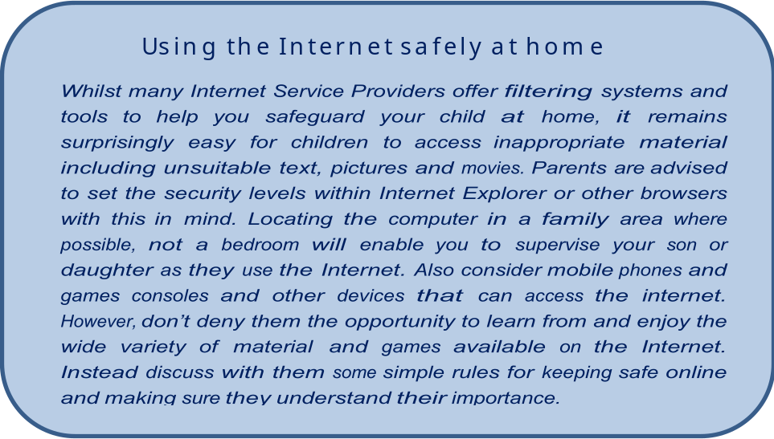

Useful Websites for Further information
NSPCC: www.nspcc.org.uk/preventing-abuse/keeping-children-safe/online-safety/parental-controls/
Childnet: www.childnet-int.org
CEOP: www.ceop.police.uk
Childline: https://www.childline.org.uk/info-advice/bullying-abuse-safety/online-mobile-safety/staying-safe-online/

