Baden Powell Times
(21/09/2023 Autumn 1)

Dear Parents or Carers,
We have once again returned after our summer break and it is wonderful to see our amazing children once again.
The children have settled very quickly and are fully engaging with their learning and showing the impeccable behaviour that we are all very proud of –and what every visitor to the school comments on.
We are looking forward to a year of possible change but please be assured that our first priority is the children and we will work to ensure that any changes have minimal impact on the children’s, and your, emotional wellbeing.
We will always strive to ensure our children and their interests are put before all else.
Mr Smith

School Uniform and PE Kit
Please remember that children should wear navy sweatshirt, navy trouser or skirt or pinafore, blue or white polo shirt and plain black school shoes with no logos for the winter period.
PE kit should be worn to school on your child’s PE day. PE kit should be black tracksuit trousers and red polo shirt.
Please remember that children should not wear jewellery to school. They should only wear small stud earing or small hoops in the ear and these should be removed on PE days before the children come to school.
As a school we do not insist that children buy uniform that has the crest on it but we very much like to see them to attend school in the correct uniform colours.

Curriculum Information is available on the school website.

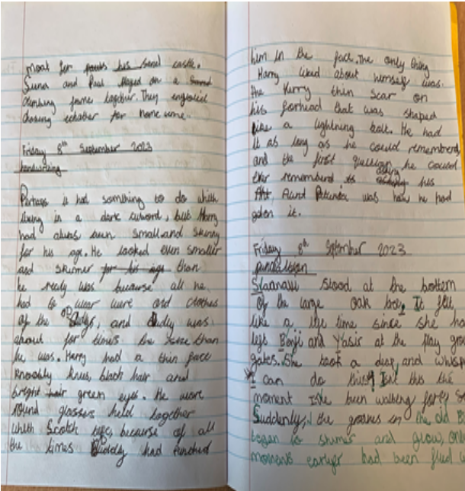

“Education is not the filling of a pail, but the lighting of a fire.”
— W.B. Yeats
Baden Powell Times
(21/09/2023 Autumn 1)

Reading
To help your child at home you could:
Read to your child every day. Children love to hear stories read to them and to read them on their own afterward. Use different voices, and tone to engage your child and show them the pleasures that the written and spoken word can bring.

Water Bottles
Please ensure your child brings a bottle of water to school or a bottle that can be filled. The school will not supply water bottles but we do have drinking water that the children can use to fill their own empty bottles.

Important Dates

October Half-Term: Monday 23rd October to Friday 27th October.
Parents Evening: Thursday 14th December 3.30pn to 7.00pm
Infants Christmas Performance: Monday 18th December 2.00pm
EYFS Christmas Performance: Tuesday 19th December 10.00am
Last Day of Term: Thursday 21st December - School closes at 1.20pm
INSET Day for staff: Monday 8th January 2024
Children return to school: Tuesday 9th January 2024
Attendance
Please remember to contact the school if your child will be absent. The school number is 020 8985 6176.
Please remember not to take family holidays during term time these will not be authorised.
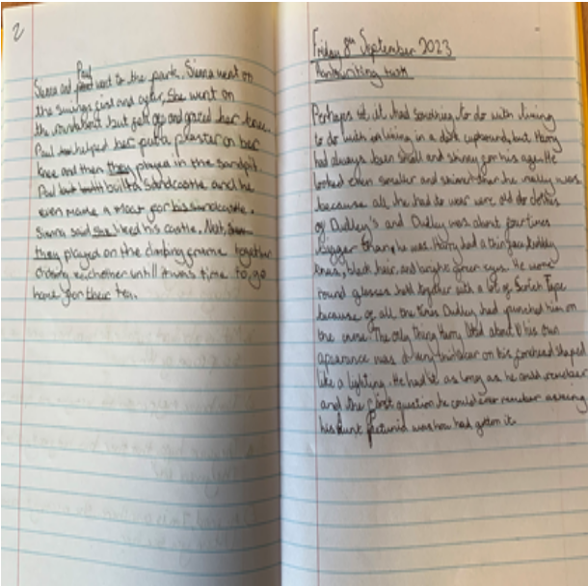
Start of Day
Please remember to keep the entry and exit points as clear as possible when children enter the school in the morning.

